**Academic Partner of Spoken Tutorials,**

**IIT Bombay**

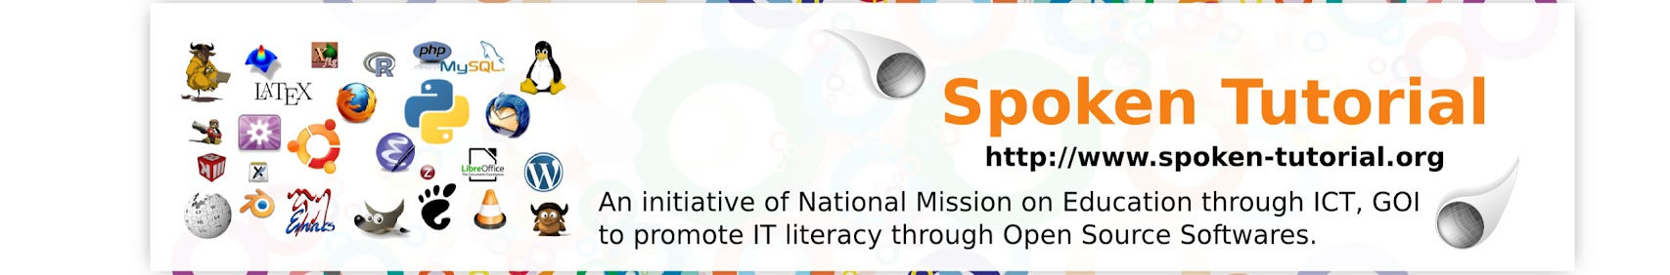

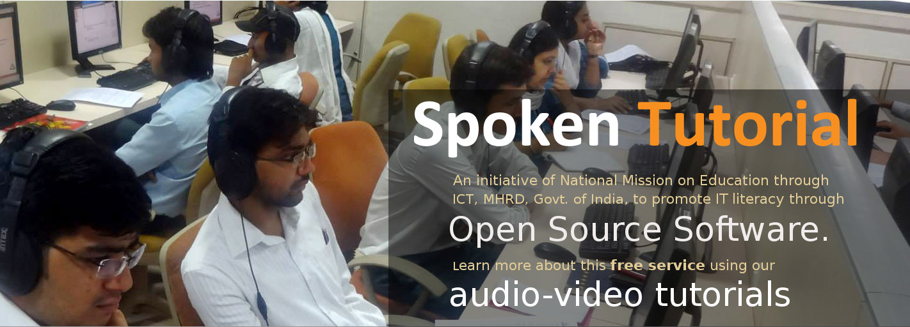

* Indian Institute of Technology Bombay has officially approved Sree Chitra Thirunal College of Engineering as an ACADEMIC PARTNER of Spoken Tutorial Programme of IIT Bombay.
* The Spoken Tutorial Project is an initiative of National Mission on Education through Information and Communication Technology (ICT), MHRD, Govt. of India, to promote IT literacy through Open Source Software.
* The main objective of this project is to promote IT literacy for education and improve the employment potential of learners in India, using FOSS (free and open source software).

